# The weight of the beehive as a measure for the activity of the bees

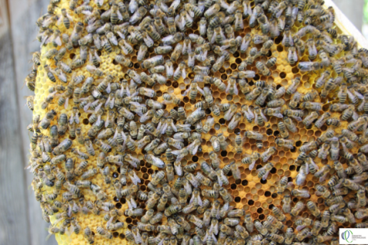Bees are proverbially „hardworking“.

Fig. : Bees on honeycomb

But how can I find out more about bees and their activities with the help of the BeeBIT data?

We cannot answer this question directly by using the BeeBIT data.

However, weight of the beehives can be used as an indirect measure for the activity of the bees.

## How does the weight of the hive change when the bees are active?

### Assumption

Check your assumption(s) by recording the change in weight of the hive during the course of a day.

1. Choose location and time period of a day from the BeeBIT data (e.g., AUT-Bie-6.08.2016, 21:00 – 09.06.2016, 23:00) and describe how the weight of the hive changes during this period.

### Observation

### C:\Dokumente und Einstellungen\Manu\Eigene Dateien\Eigene Bilder\Microsoft Clip Organizer\j0434403.wmfExplanation

1. Wie ist dieser Kurvenverlauf zu erklären?



1. Check your assumptions! Did you expect that?

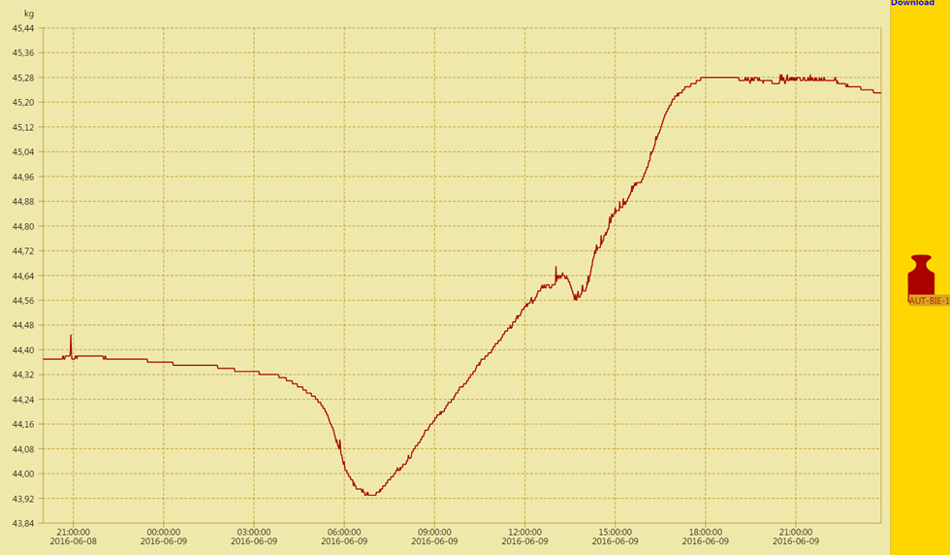

Fig. 2: The development of the weight of the hive 08.06.2016 (21:00) – 09.06.2016 (21:00) (Data from AUT-GSC 1)

### C:\Dokumente und Einstellungen\Manu\Eigene Dateien\Eigene Bilder\Microsoft Clip Organizer\j0434403.wmf Additional task pertaining to the diagram

1. What is the total weight carried by bees on this day?

Hint 1: Ponder: Weight of the hive decreases as many bees leave their hive.

Hint 2: Worker bees are “hardworking”. They constantly carry pollen and nectar to the hive.

Hint 3: Compare the weight of a hive at the same time on two consecutive days.