For centuries, honey was the only means to sweeten food in various parts of Germany. Although those days are long gone, many people still love to eat honeybuns for their breakfast. Each German consume approximately 1.4 kilos of honey per year, the highest per capita consumption worldwide. But, honey isn’t just sugar. It also contains other important nutrients. | Fig. 1: Components of honey [in %]

Honey contains Vitamin C
Honey also contains very small amounts of vitamin C.
Vitamin C or Ascorbic acid, an important organic acid, plays a very crucial physiological role in the human body.  Recommended daily intake for this vitamin is around 100 mg. Insufficient intake of this vitamin causes scurvy in humans. | 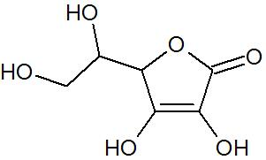  Fig. 2: Reaction of DCPIP with reducing agents

Detection of Vitamin C in honey
Color reaction with the reagent named: Tillmanns reagent can be used to determine the presence of vitamin C.  This reagent consists of a chemical named: 2.6-Dichlorophenolindophenol (DCPIP), which changes to its leuco-form in the presence of reducing agents like vitamin C (see. Figure 3). | 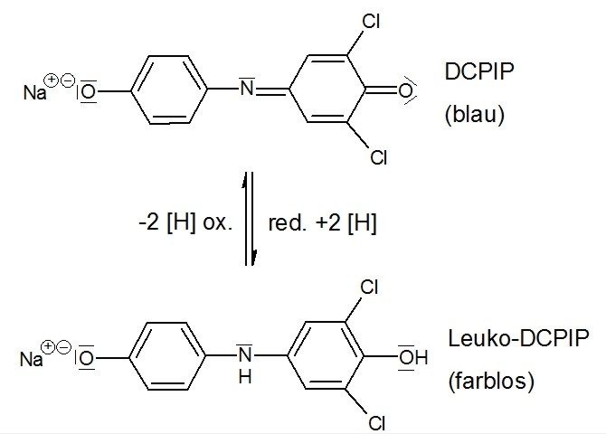  Fig. 3: Oxidation of ascorbic acid
- Explain the color change using the equation (Figure 2) given above. Explain the relevant structures in detail.

Die Ascorbinsäure wirkt als Reduktionsmittel und wird selbst oxidiert.
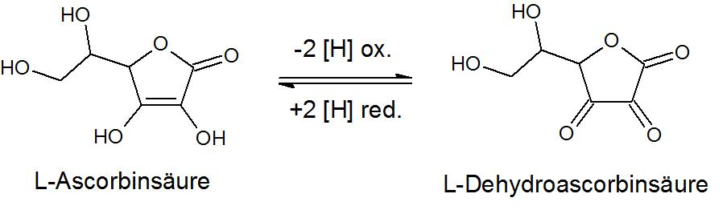
Fig.4: Oxidation of ascorbic acid
- With reference to the chemical equation shown above, explain the reaction of ascorbic acid with the Tillmanns reagent. Explain the points at which the molecules react in the Figure 4.

Procedure
Follow the procedure described below to determine the presence of vitamin C in honey:
Solution 1: Dissolve 5 g honey in 10 ml water.
Solution 2: Dissolve 5 g of ascorbic acid in water.
Take one table spoon of each of the above described aqueous solutions. Add a few drops of Tillmanns reagent (0.5 g 2.6-Dichlorphenolindiphenol (DCPIP) in 100 ml water). Stir the spoons gently in a circular motion to mix the solutions. | 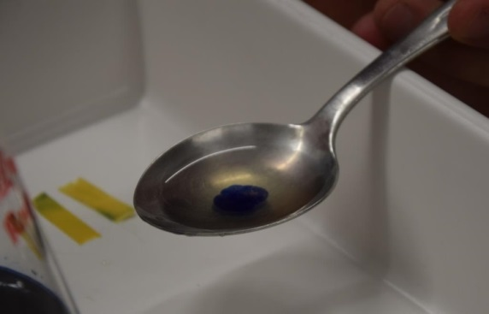  Fig. 5: Detection of vitamin C in microscale-standard

Observation

Explanation

Honey contains proteins
Honey contains proteins in small quantities. Proteins can be mainly found in pollen and also as traces of enzymes in the ripe honey. Bees add enzymes like invertase, amylase and glucose oxidase to the raw honey. However, residues of these enzymes can also be found in the ripe honey.

Test for determining the presence of proteins in honey
The Biuret test can help determine the presence of proteins, more precisely the peptide bonds. In alkaline conditions, Copper (II) ions form a violet complex with peptide groups.
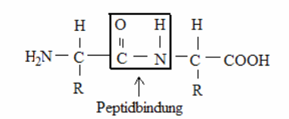
Fig. 6: Fig.6: Peptide group
To detect the presence of protein, add 2 % copper (II) sulphate solution and sodium hydroxide solution (c = 1 mol/L) to the sample/ testing solution
Use the information presented above to plan an experiment on microscale to detect the presence of protein in very small amounts (see Vitamin C).
Carefully prepare the control batch. Discuss the procedure of the planned experiment with your teacher.

Planning

Observation
The colour of the solution turns violet.

Interpretation

Deutscher Imkerbund e.V.: http://www.die-honigmacher.de/kurs3/seite_41000.html (last accessed on 23 August 2016)
0.5g 2.6-Dichlorphenolindiphenol (DCPIP) in 100 ml Wasser

