Magnetic Orientation: Using the Earth’s magnetic field for spatial orientation
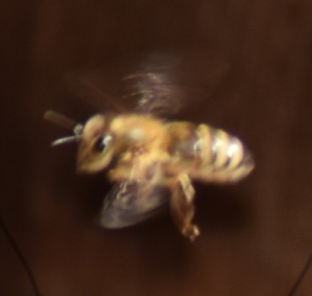
For many centuries seafarers have been using the Earth’s magnetic field to find their way across seas and oceans. When exactly the compass evolved and when it was first used for navigation is uncertain. The early mariner’s compass was made by attaching a small piece of iron at one end of a wooden stick. When Vasco da Gama and his crew found the first totally water-based route to India they too had a compass with them. But not only humans use the Earth’s magnetic field as a directional cue. Migratory birds or white whales, for instance, that travel long distances have been found to contain magnetic structures in the inner ear or elsewhere in the head that function much as compasses do. The iron-bearing mineral magnetite has been found not only in their cells but also in those of the honey-bee.
Fig. 1: Flight of a forager bee
As early as in 1968 researchers established proof that changes in the geomagnetic field have an effect on the bee’s waggle dance, i.e. ritualised movements through which it communicates spatial information to other bees. Such changes in the waggle dance’s choreography may lead to misdirection. On the other hand, there is evidence suggesting that enhancing the intensity of the weak geomagnetic field with bar magnets may improve the bee’s sense of direction. Researchers tested this hypothesis with two beehives. They manipulated one of the hives (test beehive) by applying a magnetic field in north-south orientation to intensify the Earth’s magnetic field and left the other untouched (control beehive). Both were weighed at the same time at night.
Time | Control beehive | Test beehive
Day 1 | 4.0 kg | 5.5 kg
Day 2 | 2.0 kg | 2.5 kg
Day 3 | 1.5 kg | 3.5 kg
Day 4 | 1.5 kg | 1.5 kg
Day 5 | 0.1 kg | 1.0 kg
Day 6 | 1.0 kg | 1.0 kg
Day 7 | 1.3 kg | 1.2 kg
Day 8 | 1.2 kg | 1.3 kg
Day 9 | 2.9 kg | 4.0 kg
Day 10 | 3.0 kg | 4.9 kg
Tab. 1: Daily increase in beehive mass over a period of ten sunny days

Tasks
- Use the data provided in table 1 to draw a line chart by plotting daily mass increase over time.
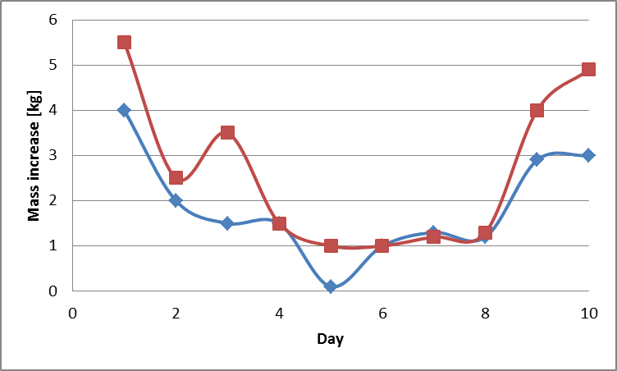
- Describe the chart.
- Present a hypothesis to explain the difference in mass increase.
- Explain in a few words why this is only a hypothesis and how it could be tested.
- Specify why the hives are weighed at the same time each night.
Hint: Go to www.beebit.de and have a look at the weight data of eHive DEU-DHG-1 from July 8 to July 10, 2016.
- The data in the diagram below was monitored by an eHive in Würzburg, Germany, in June 2016.
Examine the weight change on these two days and compare it to those observed in the test and control hives.
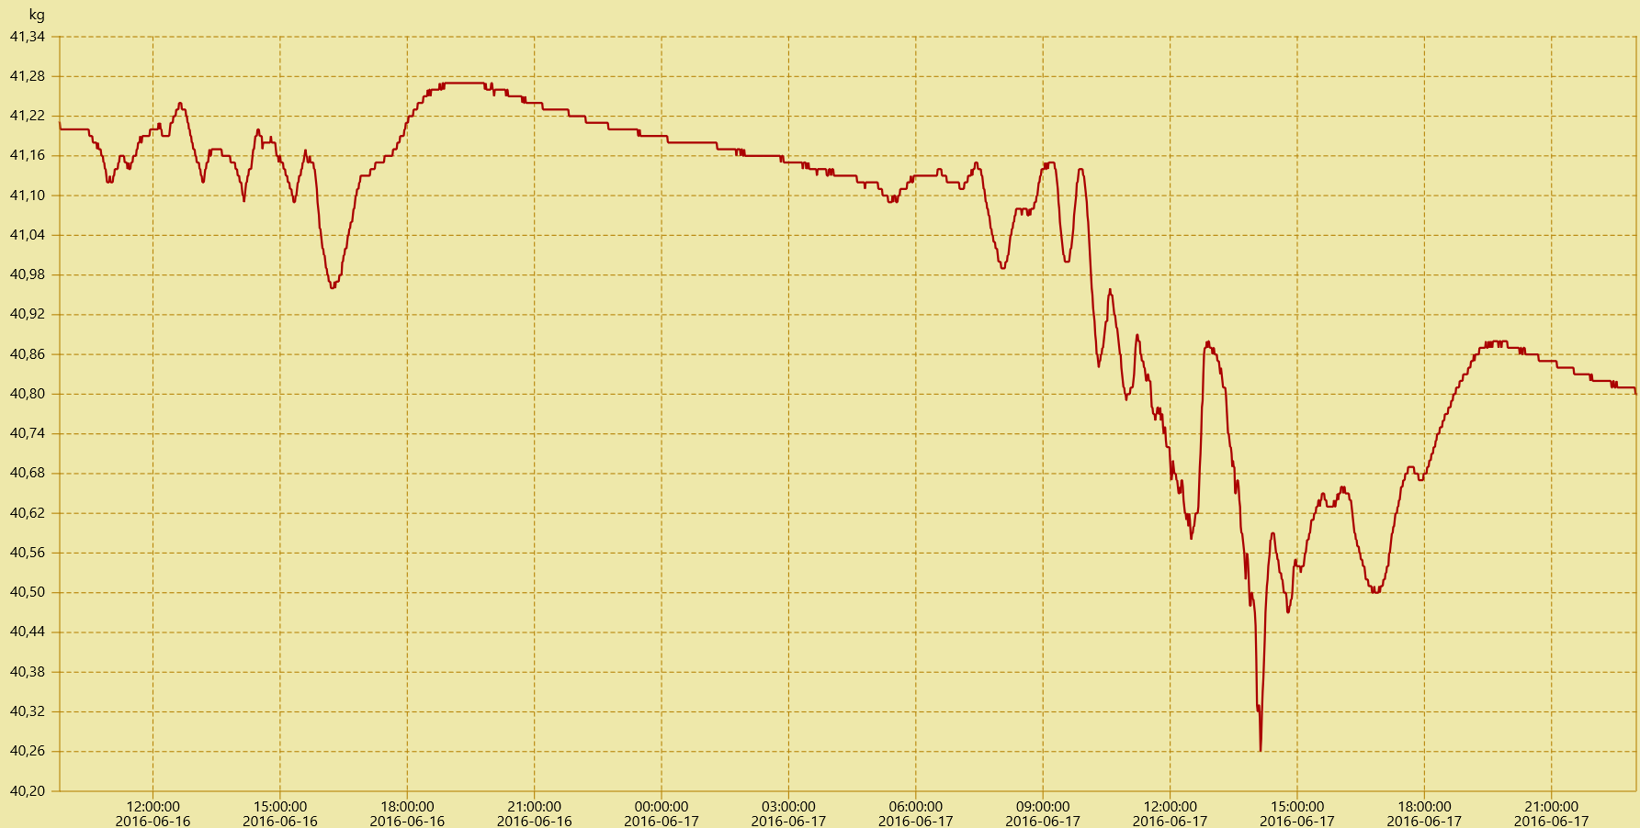
Fig. 2: Weight data of eHive DEU-DHG-1 from June 16 to June 17, 2016
- Put forward plausible hypotheses which could explain the plot in figure 3 and check them against BeeBIT data.
- In a second experiment bar magnets were applied in east-west orientation, therefore not aligning with the north-south axis of the Earth’s magnetic field.
Explain which weight changes you would expect and plot the assumed changes in the diagram of exercise 1.
- In a beekeeping journal you can find the following advice: “Don’t set up your bee colonies close to high-voltage power lines.”
Assess the plausibility of the statement.

