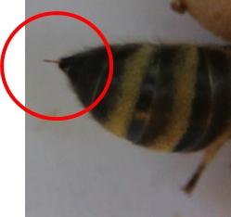
Only female bees have stingers, which means the queen bee and worker bees are the only ones that can sting. Drones cannot sting us or anyone else as they do not have any stingers.
Fig. 1: Stinger
Bees usually sting to defend themselves. This means, bees will sting only when they feel threatened. Threatened bees usually release a scent, which warns other bees to prepare for an attack.
A bee can sting a human only once. Bees have barbed stingers, which get stuck in the elastic human skin. Hence, bees usually die from injuries, while trying to pull their stingers out of an integument.
When stung by a bee, it is very important to remove the stinger as quickly as possible. Removing the stinger will reduce the amount of venom absorbed by the skin. Due to the venom injected, our integument/ skin swells at the puncture site.
Hint: The best is to stroke the stinger with your thumbnail because pulling the stinger out with two fingers can squeeze the venom sac and inject more venom into the integument.

